***RAILWAY MANAGEMENT SYSTEM***

## Term Project on Object Oriented Programming

|  |  |
| --- | --- |
| **Group Members Group 2A - E** | |
| 180041208 | Fida Kamal |
| 180041223 | Shah Jawad Islam |
| 180041229 | Alvi Aveen Khan |

**Date of Submission: 16th September, 2020**

**Course Teacher Name:** Faisal Hussain

# Introduction

The project attempts to create a database management system to supervise, control and update various parts of the national railway system. Additionally, non-administrative access is also available for customers to manage bookings.

This project could serve as a starting point for a proper management system, since it provides the basic features and is extensible.

# UML Diagram

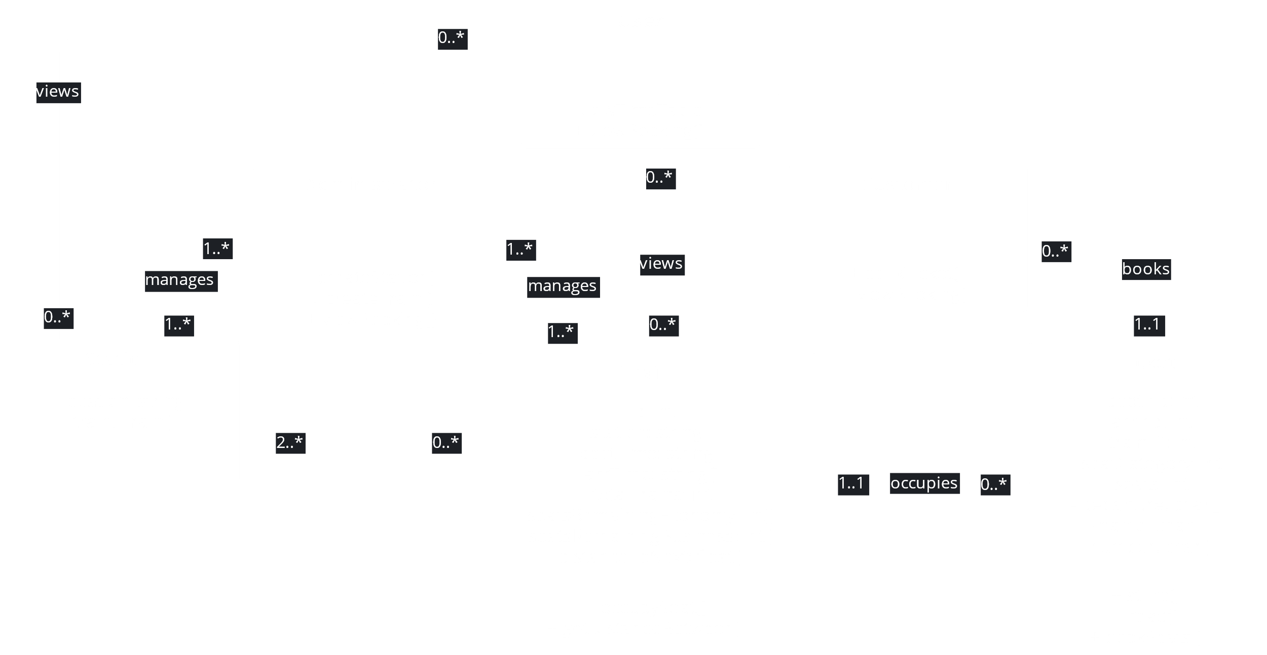

# Features

**Administrative Features**:

* Add stations and trains into the database
* View information about purchased tickets

**Non-Administrative Features**:

* Book tickets
* View information about purchased tickets

**Common Features**:

* View schedules for different stations

# Challenges

* Time constraints caused the project to not be as well-made as we had hoped.
* The final product is significantly different from the initial project. Several revisions caused code to become somewhat messy and confusing. A clear plan of exactly what would be done would have helped immensely.
* The prior point also led to memory management becoming slightly difficult.
* Not using a version control system (e.g. GitHub) caused problems in keeping the different parts of the program in sync and in handling errors that occurred during integration. This team plans to use a version control system in the future to avoid such problems. For now, high levels of coordination and frequent group meetings had to suffice.
* A railway system forces us to take into account errors that might occur due to scheduling conflicts. These errors are of a wide variety and are difficult to even contemplate let alone resolve within the program. Every effort was made to handle such errors within the program, but the extent to which this goal was accomplished does not satisfy this team.
* Projects such as this one would benefit immensely if a proper database, such as SQL, was used to handle the actual data. Attempting to keep a file-based data management system error-free and consistent has left the team feeling doubtful of their own work. An attempt was made to ease this process by using binary object data instead of simple text, but this proved difficult, especially since the change was attempted after a large portion of the project was already complete.

# Future Works

* Administrative login page
* Removing trains and stations
* Cancelling bookings
* Accommodating different schedules for different dates
* Accommodating delays in schedules